**Minimum Window Substring**

Question

Given two strings s and t, return *the minimum window in s which will contain all the characters in t*. If there is no such window in s that covers all characters in t, return *the empty string ""*.

**Note** that If there is such a window, it is guaranteed that there will always be only one unique minimum window in s.

**Example 1:**

**Input:** s = "ADOBECODEBANC", t = "ABC"

**Output:** "BANC"

**Example 2:**

**Input:** s = "a", t = "a"

**Output:** "a"

**Constraints:**

* 1 <= s.length, t.length <= 105
* s and t consist of English letters.

**Follow up:** Could you find an algorithm that runs in O(n) time?

   Hide Hint #1

Use two pointers to create a window of letters in **S**, which would have all the characters from **T**.

   Hide Hint #2

Since you have to find the minimum window in **S** which has all the characters from **T**, you need to expand and contract the window using the two pointers and keep checking the window for all the characters. This approach is also called Sliding Window Approach.

L ------------------------ R , Suppose this is the window that contains all characters of **T**

        L----------------- R , this is the contracted window. We found a smaller window that still contains all the characters in **T**

When the window is no longer valid, start expanding again using the right pointer.

# **Solution**

#### **Approach 1: Sliding Window**

**Intuition**

The question asks us to return the minimum window from the string S*S* which has all the characters of the string T*T*. Let us call a window desirable if it has all the characters from T*T*.

We can use a simple sliding window approach to solve this problem.

In any sliding window based problem we have two pointers. One right*right* pointer whose job is to expand the current window and then we have the left*left* pointer whose job is to contract a given window. At any point in time only one of these pointers move and the other one remains fixed.

The solution is pretty intuitive. We keep expanding the window by moving the right pointer. When the window has all the desired characters, we contract (if possible) and save the smallest window till now.

The answer is the smallest desirable window.

For eg. S = "ABAACBAB" T = "ABC". Then our answer window is "ACB" and shown below is one of the possible desirable windows.

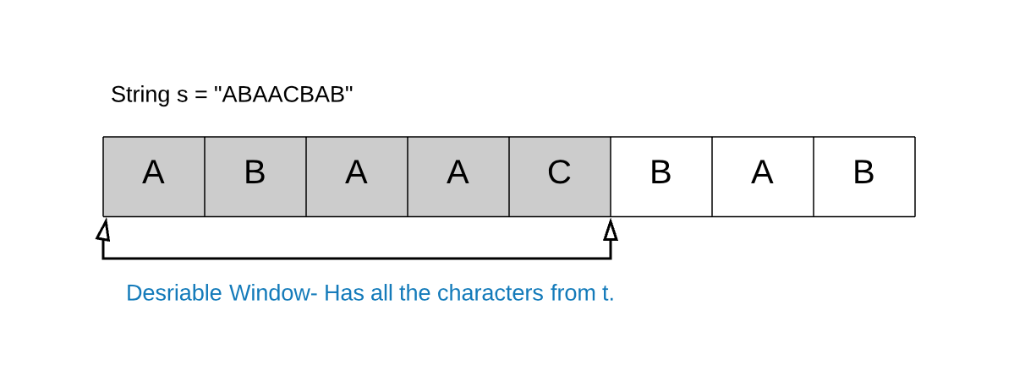

**Algorithm**

1. We start with two pointers, left*left* and right*right* initially pointing to the first element of the string S*S*.
2. We use the right*right* pointer to expand the window until we get a desirable window i.e. a window that contains all of the characters of T*T*.
3. Once we have a window with all the characters, we can move the left pointer ahead one by one. If the window is still a desirable one we keep on updating the minimum window size.
4. If the window is not desirable any more, we repeat step \; 2*step*2 onwards.

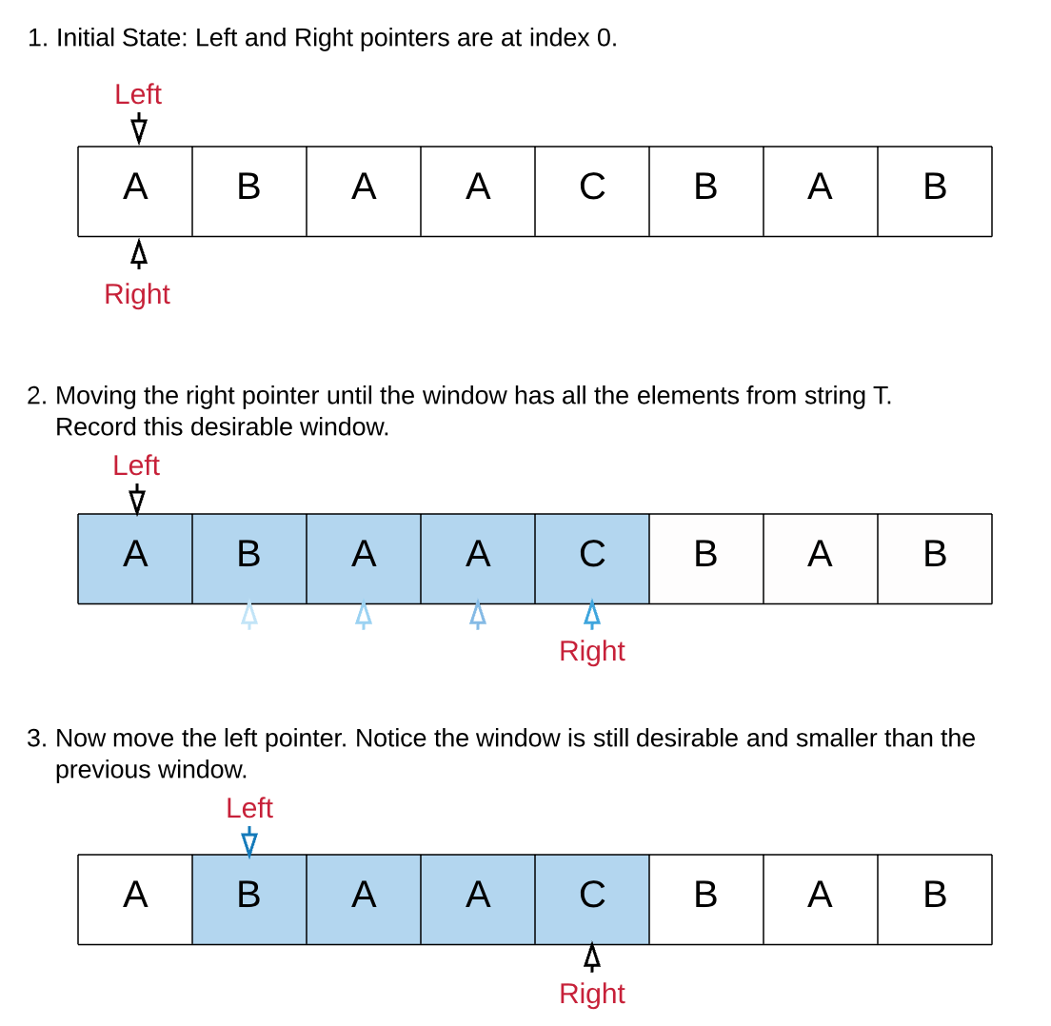

The above steps are repeated until we have looked at all the windows. The smallest window is returned.

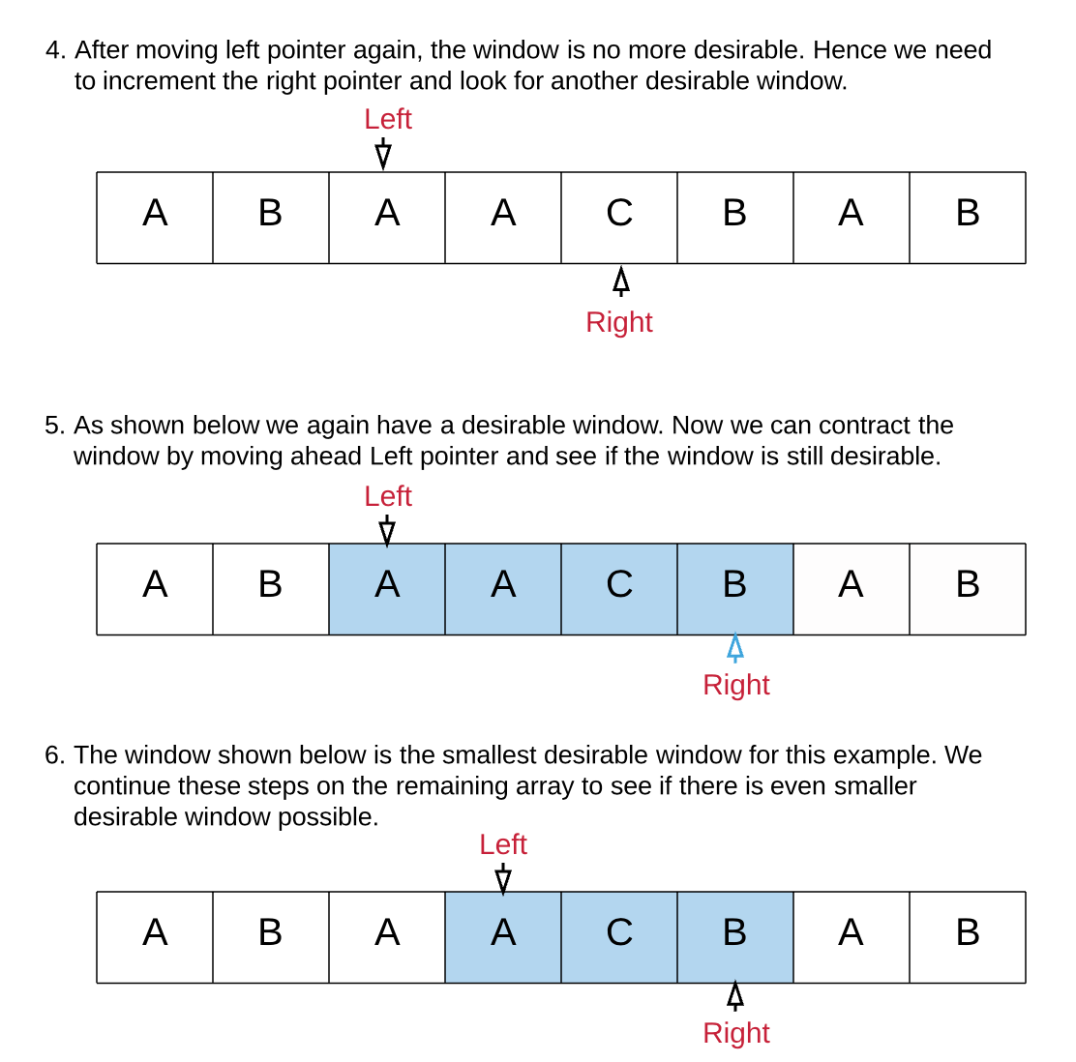

Coding Solution

Java

|  |
| --- |
| class Solution {public String minWindow(String s, String t) {if (s.length() == 0 || t.length() == 0) {return "";}// Dictionary which keeps a count of all the unique characters in t.Map<Character, Integer> dictT = new HashMap<Character, Integer>();for (int i = 0; i < t.length(); i++) {int count = dictT.getOrDefault(t.charAt(i), 0);dictT.put(t.charAt(i), count + 1);}// Number of unique characters in t, which need to be present in the desired window.int required = dictT.size();// Left and Right pointerint l = 0, r = 0;// formed is used to keep track of how many unique characters in t// are present in the current window in its desired frequency.// e.g. if t is "AABC" then the window must have two A's, one B and one C.// Thus formed would be = 3 when all these conditions are met.int formed = 0;// Dictionary which keeps a count of all the unique characters in the current window.Map<Character, Integer> windowCounts = new HashMap<Character, Integer>();// ans list of the form (window length, left, right)int[] ans = {-1, 0, 0};while (r < s.length()) {// Add one character from the right to the windowchar c = s.charAt(r);int count = windowCounts.getOrDefault(c, 0);windowCounts.put(c, count + 1);// If the frequency of the current character added equals to the// desired count in t then increment the formed count by 1.if (dictT.containsKey(c) && windowCounts.get(c).intValue() == dictT.get(c).intValue()) {formed++;}// Try and contract the window till the point where it ceases to be 'desirable'.while (l <= r && formed == required) {c = s.charAt(l);// Save the smallest window until now.if (ans[0] == -1 || r - l + 1 < ans[0]) {ans[0] = r - l + 1;ans[1] = l;ans[2] = r;}// The character at the position pointed by the// `Left` pointer is no longer a part of the window.windowCounts.put(c, windowCounts.get(c) - 1);if (dictT.containsKey(c) && windowCounts.get(c).intValue() < dictT.get(c).intValue()) {formed--;}// Move the left pointer ahead, this would help to look for a new window.l++;}// Keep expanding the window once we are done contracting.r++;}return ans[0] == -1 ? "" : s.substring(ans[1], ans[2] + 1);}} |

#### Python3

|  |
| --- |
| def minWindow(self, s, t):  """  :type s: str  :type t: str  :rtype: str  """  if not t or not s:  return ""  # Dictionary which keeps a count of all the unique characters in t.  dict_t = Counter(t)  # Number of unique characters in t, which need to be present in the desired window.  required = len(dict_t)  # left and right pointer  l, r = 0, 0  # formed is used to keep track of how many unique characters in t are present in the current window in its desired frequency.  # e.g. if t is "AABC" then the window must have two A's, one B and one C. Thus formed would be = 3 when all these conditions are met.  formed = 0  # Dictionary which keeps a count of all the unique characters in the current window.  window_counts = {}  # ans tuple of the form (window length, left, right)  ans = float("inf"), None, None  while r < len(s):  # Add one character from the right to the window  character = s[r]  window_counts[character] = window_counts.get(character, 0) + 1  # If the frequency of the current character added equals to the desired count in t then increment the formed count by 1.  if character in dict_t and window_counts[character] == dict_t[character]:  formed += 1  # Try and contract the window till the point where it ceases to be 'desirable'.  while l <= r and formed == required:  character = s[l]  # Save the smallest window until now.  if r - l + 1 < ans[0]:  ans = (r - l + 1, l, r)  # The character at the position pointed by the `left` pointer is no longer a part of the window.  window_counts[character] -= 1  if character in dict_t and window_counts[character] < dict_t[character]:  formed -= 1  # Move the left pointer ahead, this would help to look for a new window.  l += 1  # Keep expanding the window once we are done contracting.  r += 1  return "" if ans[0] == float("inf") else s[ans[1] : ans[2] + 1] |

**Complexity Analysis**

* Time Complexity: O(|S| + |T|)*O*(∣*S*∣+∣*T*∣) where |S| and |T| represent the lengths of strings S*S* and T*T*. In the worst case we might end up visiting every element of string S*S* twice, once by left pointer and once by right pointer. |T|∣*T*∣ represents the length of string T*T*.
* Space Complexity: O(|S| + |T|)*O*(∣*S*∣+∣*T*∣). |S|∣*S*∣ when the window size is equal to the entire string S*S*. |T|∣*T*∣ when T*T* has all unique characters.

#### **Approach 2: Optimized Sliding Window**

**Intuition**

A small improvement to the above approach can reduce the time complexity of the algorithm to O(2*|filtered\_S| + |S| + |T|)*O*(2∗∣*filtered*_*S*∣+∣*S*∣+∣*T*∣), where filtered\_S*filtered*_*S* is the string formed from S by removing all the elements not present in T*T*.

This complexity reduction is evident when |filtered\_S| <<< |S|∣*filtered*_*S*∣<<<∣*S*∣.

This kind of scenario might happen when length of string T*T* is way too small than the length of string S*S* and string S*S* consists of numerous characters which are not present in T*T*.

**Algorithm**

We create a list called filtered\_S*filtered*_*S* which has all the characters from string S*S* along with their indices in S*S*, but these characters should be present in T*T*.

S = "ABCDDDDDDEEAFFBC" T = "ABC"

filtered_S = [(0, 'A'), (1, 'B'), (2, 'C'), (11, 'A'), (14, 'B'), (15, 'C')]

Here (0, 'A') means in string S character A is at index 0.

We can now follow our sliding window approach on the smaller string filtered\_S*filtered*_*S*.

Coding Solution

Java

|  |
| --- |
| class Solution {  public String minWindow(String s, String t) {  if (s.length() == 0 || t.length() == 0) {  return "";  }  Map<Character, Integer> dictT = new HashMap<Character, Integer>();  for (int i = 0; i < t.length(); i++) {  int count = dictT.getOrDefault(t.charAt(i), 0);  dictT.put(t.charAt(i), count + 1);  }  int required = dictT.size();  // Filter all the characters from s into a new list along with their index.  // The filtering criteria is that the character should be present in t.  List<Pair<Integer, Character>> filteredS = new ArrayList<Pair<Integer, Character>>();  for (int i = 0; i < s.length(); i++) {  char c = s.charAt(i);  if (dictT.containsKey(c)) {  filteredS.add(new Pair<Integer, Character>(i, c));  }  }  int l = 0, r = 0, formed = 0;  Map<Character, Integer> windowCounts = new HashMap<Character, Integer>();  int[] ans = {-1, 0, 0};  // Look for the characters only in the filtered list instead of entire s.  // This helps to reduce our search.  // Hence, we follow the sliding window approach on as small list.  while (r < filteredS.size()) {  char c = filteredS.get(r).getValue();  int count = windowCounts.getOrDefault(c, 0);  windowCounts.put(c, count + 1);  if (dictT.containsKey(c) && windowCounts.get(c).intValue() == dictT.get(c).intValue()) {  formed++;  }  // Try and contract the window till the point where it ceases to be 'desirable'.  while (l <= r && formed == required) {  c = filteredS.get(l).getValue();  // Save the smallest window until now.  int end = filteredS.get(r).getKey();  int start = filteredS.get(l).getKey();  if (ans[0] == -1 || end - start + 1 < ans[0]) {  ans[0] = end - start + 1;  ans[1] = start;  ans[2] = end;  }  windowCounts.put(c, windowCounts.get(c) - 1);  if (dictT.containsKey(c) && windowCounts.get(c).intValue() < dictT.get(c).intValue()) {  formed--;  }  l++;  }  r++;  }  return ans[0] == -1 ? "" : s.substring(ans[1], ans[2] + 1);  }  } |

Python3

|  |
| --- |
| def minWindow(self, s, t):  """  :type s: str  :type t: str  :rtype: str  """  if not t or not s:  return ""  dict_t = Counter(t)  required = len(dict_t)  # Filter all the characters from s into a new list along with their index.  # The filtering criteria is that the character should be present in t.  filtered_s = []  for i, char in enumerate(s):  if char in dict_t:  filtered_s.append((i, char))  l, r = 0, 0  formed = 0  window_counts = {}  ans = float("inf"), None, None  # Look for the characters only in the filtered list instead of entire s. This helps to reduce our search.  # Hence, we follow the sliding window approach on as small list.  while r < len(filtered_s):  character = filtered_s[r][1]  window_counts[character] = window_counts.get(character, 0) + 1  if window_counts[character] == dict_t[character]:  formed += 1  # If the current window has all the characters in desired frequencies i.e. t is present in the window  while l <= r and formed == required:  character = filtered_s[l][1]  # Save the smallest window until now.  end = filtered_s[r][0]  start = filtered_s[l][0]  if end - start + 1 < ans[0]:  ans = (end - start + 1, start, end)  window_counts[character] -= 1  if window_counts[character] < dict_t[character]:  formed -= 1  l += 1  r += 1  return "" if ans[0] == float("inf") else s[ans[1] : ans[2] + 1] |

**Complexity Analysis**

* Time Complexity : O(|S| + |T|)*O*(∣*S*∣+∣*T*∣) where |S| and |T| represent the lengths of strings S*S* and T*T*. The complexity is same as the previous approach. But in certain cases where |filtered\_S|∣*filtered*_*S*∣ <<< |S|∣*S*∣, the complexity would reduce because the number of iterations would be 2*|filtered\_S| + |S| + |T|2∗∣*filtered*_*S*∣+∣*S*∣+∣*T*∣.
* Space Complexity : O(|S| + |T|)*O*(∣*S*∣+∣*T*∣).